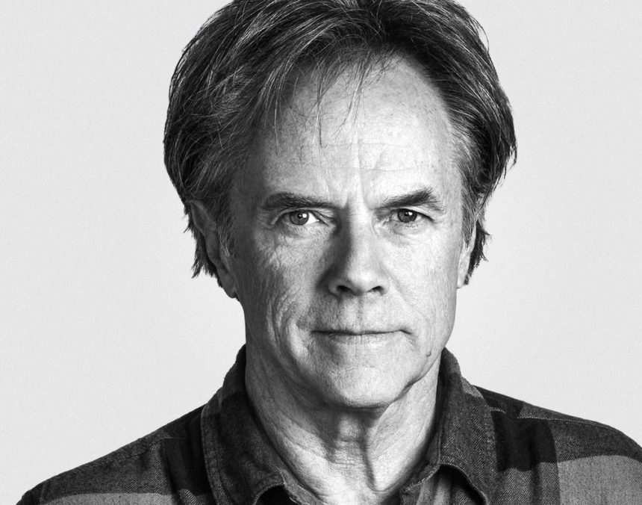

<https://go.distance.ncsu.edu/gd203/wp-content/uploads/2020/04/david123-860x676.jpeg>

 <https://www.google.com/url?sa=i&url=https%3A%2F%2Fwww.davidairey.com%2Fdavid-carson-all-for-a-few-good-waves&psig=AOvVaw2Qglx2bYgRAJoJzappxKiO&ust=1601232198019000&source=images&cd=vfe&ved=0CAIQjRxqFwoTCLDbw_W8h-wCFQAAAAAdAAAAABAD>